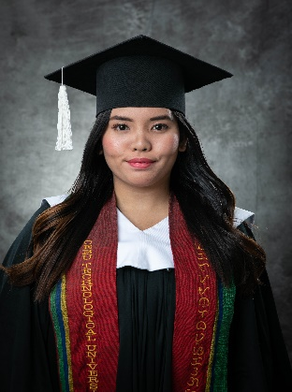
NERIZZA VILLARICO DAMAYO

Babag II, Lapu-Lapu City
Mobile: 09397820708
Telephone: 341-9917
Email: nerizzadamayo0813@gmail.com

Career Objective

- To enhance the current knowledge and skills I possess. To be able to work in a fast –paced environment.

Personal Profile

Name: Nerizza Villarico Damayo
Nick Name: Rosalinda
Date of Birth: August 13, 2000
Age: 25 y/o
Place of Birth: Babag II, Lapu- Lapu City
Sex: Female
Marital Status: Single
Nationality: Filipino
Languages Known: English. Bisaya, Tagalog

Basic Academic Credentials

College

Cebu Technological University (Main Campus)
M. J Cuenco, Cebu City
Bachelor of Public Administration
Date Graduated: August 2023

Senior High School

Asian Learning Center
Pajo Lapu-Lapu City
Awards: With Honors
Date Graduated: March 2019

High School
Babag National High School
Babag 1, Lapu-Lapu City
Date Graduated: April 2017
Elementary

Babag II, Elementary School
Babag II, Lapu-Lapu City
Awards : With Honor
Date Graduated: April 2012

Work Experience

Company Name : Sykes Asia
Role : Customer Service Rep.
Date Started: April 2022
Date Ended: August 2023

Company Name: Concentrix
Role: Technical Support
Date Started: September 2023

Company Name: Newfold Digital Philippines
Role: Wordpress Live Specialist
Date Started: October 2024

Personal Skills

- Ability to rapidly build relationship and set up trust
- Confident and Determined
- Ability to cope up with different situations
- Good time management
- Hard worker
- Creative and Innovative
- Efficient in handling pressures
Declaration

I do hereby declare that the above information is true to the best of my knowledge.

NERIZZA VILLARICO DAMAYO

